11.6 Making salts (PartⅡ)
Name: ____________________ Class: ____________________ Due date: 12.7
1. Lead iodide is insoluble in water.
Lead iodide is made by adding aqueous lead nitrate to aqueous potassium iodide.
Which pieces of apparatus are needed to obtain solid lead iodide from $20cm^{3}$ of aqueous lead nitrate? （ ）
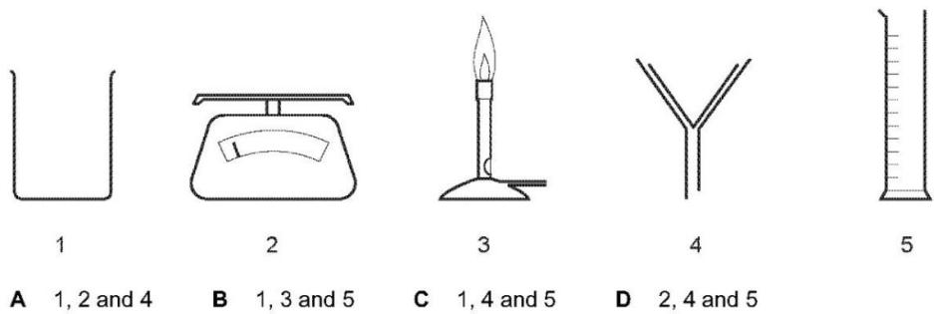

2. Barium sulfate is an insoluble salt.
It can be made by reacting copper(II) sulfate solution with barium nitrate solution.
$$CuSO_{4}(aq)+Ba(NO_{3})_{2}(aq)→Cu(NO_{3})_{2}(aq)+BaSO_{4}(s)$$
What is the correct order of steps to obtain a pure, dry sample of barium sulfate from the reaction mixture? （ ）
 | step 1 | step 2 | step 3
A | filter | evaporate the filtrate to dryness | leave the solid formed to cool
B | filter | evaporate the filtrate to the point of crystallisation | leave the filtrate to cool
C | filter | leave the residue in a warm place to dry | wash the residue with water
D | filter | wash the residue with water | leave the residue in a warm place to dry

3. The solubility of some salts is shown.
 | chloride | nitrate | sulfate | carbonate
barium | soluble | soluble | insoluble | insoluble
lead(II) | insoluble | soluble | insoluble | insoluble
potassium | soluble | soluble | soluble | soluble
zinc | soluble | soluble | soluble | insoluble
Which two aqueous solutions produce an insoluble salt when mixed together?（ ）
A barium chloride and zinc nitrate
B barium nitrate and lead(II) nitrate
C lead(II) nitrate and potassium carbonate
D potassium nitrate and zinc sulfate

4. A method used to make copper(II) sulfate crystals is shown.
1 Place dilute sulfuric acid in a beaker.
2 Warm the acid.
3 Add copper(II) oxide until it is in excess.
4 Filter the mixture.
5 Evaporate the filtrate until crystals start to form.
6 Leave the filtrate to cool.
What are the purposes of step 3 and step 4? （ ）
 | step 3 | step 4
A | to ensure all of the acid has reacted | to obtain solid copper(II) sulfate
B | to ensure all of the acid has reacted | to remove the excess of copper(II) oxide
C | to speed up the reaction | to obtain solid copper(II) sulfate
D | to speed up the reaction | to remove the excess of copper(II) oxide

5. Lead(II) sulfate is an insoluble salt.
Which process is not used to prepare a pure sample of this salt? （ ）
A crystallisation B drying C filtration D precipitation

6. Lead(II) iodide is formed as a precipitate in the reaction shown.
$$Pb(NO_{3})_{2}(aq)+2NaI(aq)→PbI_{2}(s)+2NaNO_{3}(aq)$$
Which method is used to separate the lead(II) iodide from the mixture? （ ）
A crystallisation B distillation C evaporation D filtration

7. Lead(II) sulfate is an insoluble salt.
Which reaction produces a mixture from which lead(II) sulfate is obtained by filtration? （ ）
A adding solid lead(II) carbonate to dilute sulfuric acid
B adding solid lead(II) hydroxide to dilute sulfuric acid
C adding metallic lead to dilute sulfuric acid
D adding aqueous lead(II) nitrate to dilute sulfuric acid

8. A student reacted excess iron powder with sulfuric acid to prepare a solution of iron(II)sulfate.The diagram shows the procedure followed in three stages
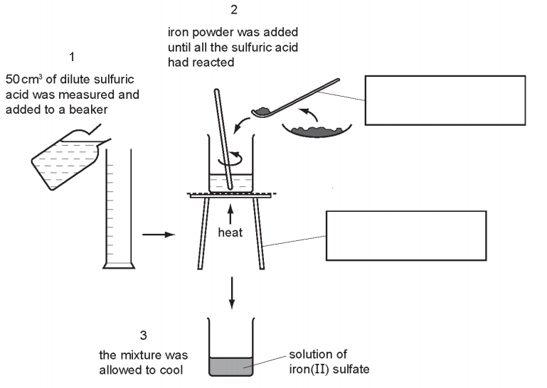
(a)Complete the boxes to identify the pieces of apparatus labelled,
(b) How would the student know when all of the sulfuric acid had reacted?
Give two reasons
..................................................................................................................................
..................................................................................................................................
9.
